**Enumerated Datatypes and Typedefs assignments**

**Mandatory**

**1. WAP to define an enum to store designations in an organization. List of possible values are**

**{E2F=1, E2, E3, E4, E5}**

**Prompt and read a designation from the user. Then display his designation string such as**

**Designation Designation String**

**E2F Software Fresher**

**E2 Software Engineer**

**E3 Senior Software Engineer**

**E4 Team Lead**

**E5 Senior Team Lead**

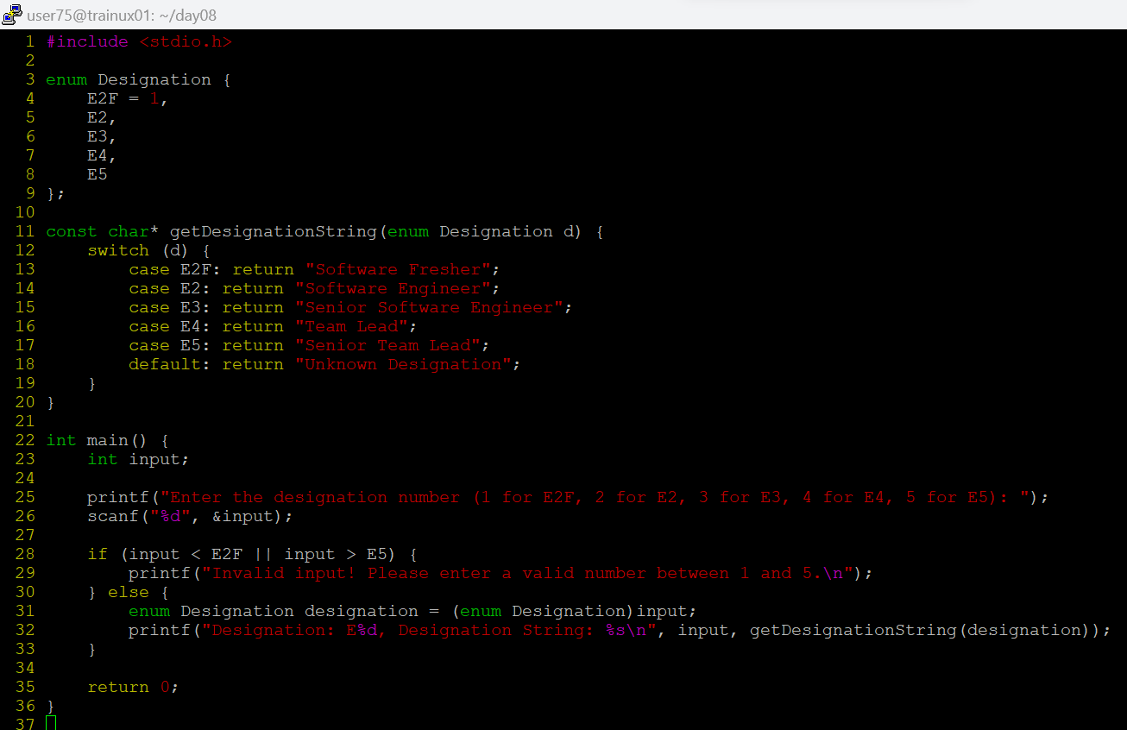

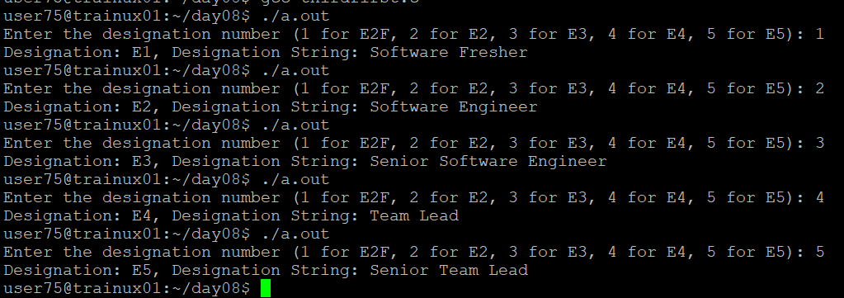

**2. Define a typedef structure to keep the configuration of putty server. Identify and place all the required members. Create a structure variable and initialize it with user defined values and finally display the contents.**



